|  |
| --- |
| Bellevue University |
| A Study of Health Benefits Offered by Employers |
| Additional Health Benefits that Could Increase Employee Satisfaction |
|  |
| **Christine Hathaway** |
| **2/29/2020** |

|  |
| --- |
|  |

Executive Summary

Employee satisfaction and retention is a challenge every company faces. Finding qualified staff to fill a position can be a costly and time consuming endeavor. But hiring is only the first step. Employee retention is the key to keeping down hiring costs. One key to retaining employees is job satisfaction. An employee that finds fulfillment in their position is less likely to leave a company

One way to increase employee satisfaction is through benefits. Many companies offer health benefits, vacation, sick leave, maternity, etc. The question becomes, which benefits lead to the most employee satisfaction, thus leading to higher levels of retention.

This study used the data from the 2018 National Center for Health Statistics (NCHS) to examine the health concerns of the population. The survey covered a range of questions delivered to families and individuals, looking at their overall health status, employment status, whether or not they had coverage, and what types of coverage they had. It also looked at employer benefits, and how often medical was needed and either delayed or not received. The purpose of the study then focused on finding any significant areas that an employer could impact in a positive way to aid in employee satisfaction.

The data files were examined and analyzed in detail to look for any relationships between the variables. Modeling was created that looked for significant correlations between the variables. The analysis revealed that paid sick leave had one of the biggest impacts on a respondent seeking and receiving medical care. Therefore, employers should offer or enhance their paid sick leave policies to increase employee satisfaction.

Intro/Background of the Problem

The National Center for Health Statistics (NCHS) conducts annual surveys across the population. The datasets, results, and other relevant information are published on the Centers for Disease Control and Prevention website and available for public use. “The National Health Interview Survey (NHIS) is the principal source of information on the health of the civilian noninstitutionalized population of the United States and is one of the major data collection programs of the NCHS. The main objective of the NHIS is to monitor the health of the United States population through the collection and analysis of data on a broad range of health topics. A major strength of this survey lies in the ability to categorize these health characteristics by many demographic and socioeconomic characteristics” (National Center for Health Statistics, 2019).

The datasets are categorized into five different subsets of files: household, family, person, sample child, and sample adult. The Household File is derived largely from the Household Composition section of the Core and describes characteristics of each household. This file is considered as the base file from which all other files are built. The Family File contains variables that describe characteristics of the 30,309 families living in households that participated in the 2018 NHIS. The variables contained in the Family file are reconstructions of the person-level data from the Core sections at the family level. The Person File variables are derived from the sections making up the Family Core of the NHIS. The information in the Family Core questionnaire is collected for all household members and includes Health Status and Limitation of Movement, Health Care Access and Health Insurance. The Sample Child section of the 2018 NHIS covers additional subject areas not included in the Family Core. Moreover, the questions in the Sample Child section are more specific and are intended to gather more detailed information than those in the Family Core. The Sample Adult section of the NHIS covers many of the subject areas included in the Family Core. However, the questions in the Sample Adult section are more specific and are intended to gather more detailed information.

This project addressed the following problem statement: What health benefits, in addition to health insurance, could an employer offer that would be most valued by employees, in turn leading to better employee retention? The project utilized the 2018 surveys from the NCHS. Details and data regarding demographics and the surveys are also available from the National Health Interview Survey Description document. The sample size of the surveys varies from year to year. The 2018 surveys contain data for 29,839 households containing 72,831 persons in 30,309 families. The number of sample children was 8,269 and the number of sample adults was 25,417. The total household response rate was 64.2%: 26.0 percentage points of the 35.8% non-interview rate were the result of respondent refusal and unacceptable “insufficient” partial interviews. The remaining 9.8 percentage points were primarily the result of failure to locate an eligible respondent at home after repeated contact attempts (National Center for Health Statistics, 2019).

The data in the files covers many different aspects of health, types of medications, types of health coverage, various levels of mobility, employment history, etc. It includes data not just on family units, but sampled adult and child respondents and includes their answers to extensive questioning. Because of the number and size of the data files, the scope of the analysis was narrowed to exclude information regarding children. Based on the business questions, the study focused on health coverage offered by employers, not through other avenues or types of coverage.

Methods

Exploratory data analysis was conducted using Python, R, and Power BI. Summaries, descriptions and statistics were performed on all of the datasets for an in-depth understanding of the variables. Variables of interest include paid sick leave, satisfaction of coverage, what services were unaffordable, how recent were visits to various doctors, difficulty with various activities, how recent did various illnesses occur, whether certain illnesses had ever occurred, and current prescriptions. Other variables include whether or not coverage was incurred, and reasons it wasn’t, difficulty of paying for medical bills, and reasons for not working. The correlation of the amount of times medical care was needed and delayed or not received, compared to whether they had insurance coverage, was also explored.

Exploratory analysis revealed numerous ways to look at all of the data available. Variables covered the types and levels of health conditions, frequency of screenings, vaccinations, anxiety, depression, alcohol consumption, smoking, limitations due to conditions, hearing, vision, and dental. Some of the most frequent health conditions included back/neck, arthritis, musculoskeletal, depression, heart and hypertension, and diabetes. Data also included insurance coverage from various providers, such as private, Medicare, Medicaid, and on exchange. After examinations of the data files, the “person” and “sample adult” files became the focus of deeper analysis.

The “person” data set offered in depth information on variables such as: Types of coverage offered through insurance; Reasons respondents did not have health coverage; Difficulties in making payments for medical services; Reasons respondents are not working; and Whether or not respondents delayed getting/did not receive medical care.

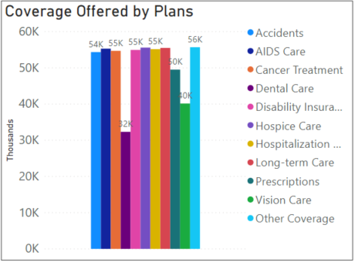

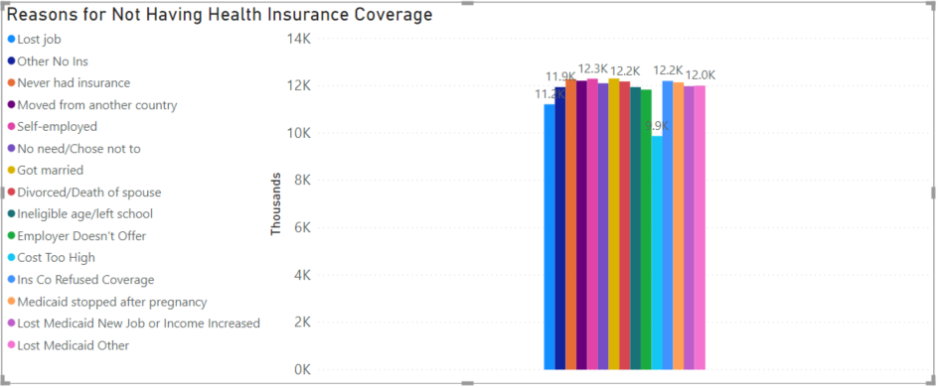

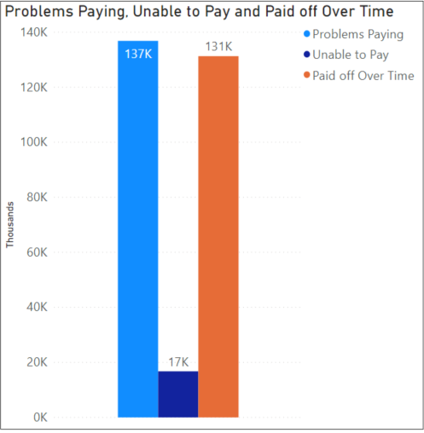

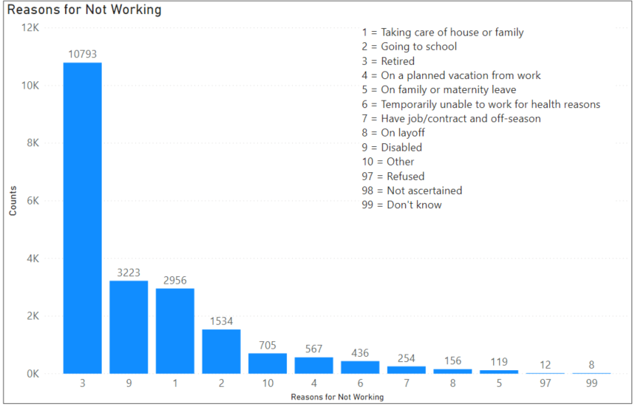

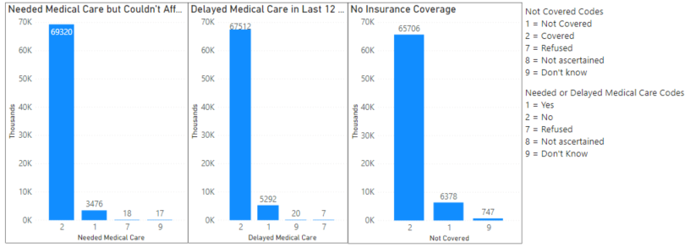

The analysis of the “person” data file revealed the following results, some of which were surprising. Vision/Dental/Prescription were the least common types of insurance coverage – the study initially expected these to be more common than cancer or AIDS. The main reason for the respondent not having insurance was that their employer doesn’t offer it, which was more frequent than that that the costs of insurance were too high. Having difficulty paying or paying over a time period was more frequent than having the inability to pay for medical care. The most common reason for not working was retirement, while disability was the second highest, and health reasons was the seventh. Finally, a majority of people have health care coverage of some type.

The “sample adult” data set contained more details on additional variable such as: Did the respondent have paid sick time with their employer; How satisfied are they with their health care; How often could they not afford different types of medical care; How often did they seek medical care; What types of health issues do they have; What types of screenings or care have they had; Have they ever been told they have certain conditions; Are they taking prescriptions; and Do they have limitations due to their illness.

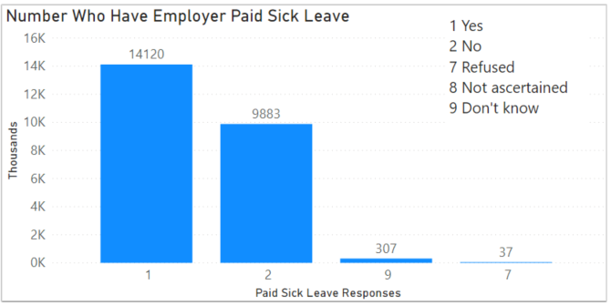

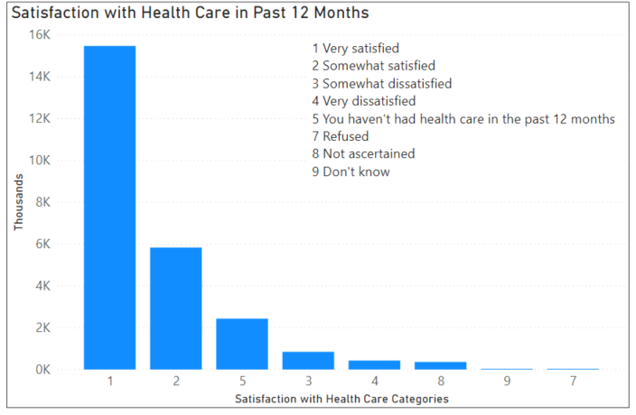

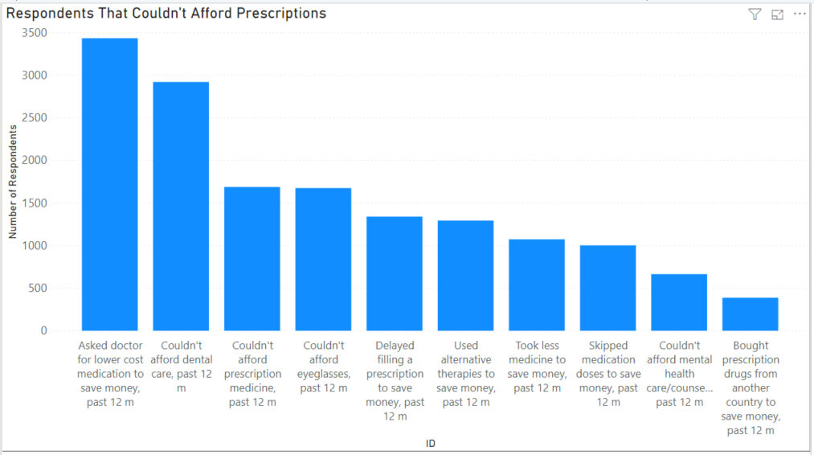

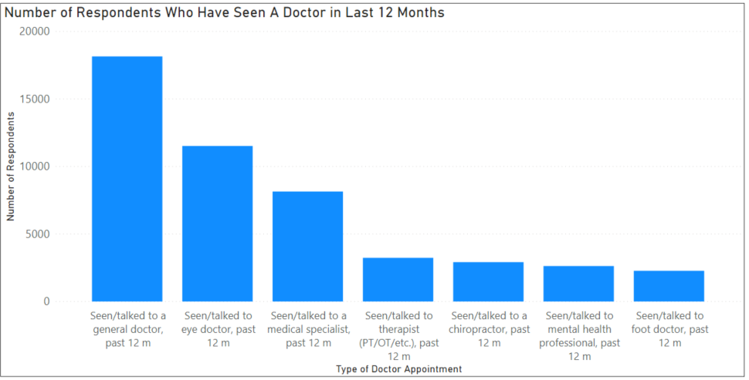

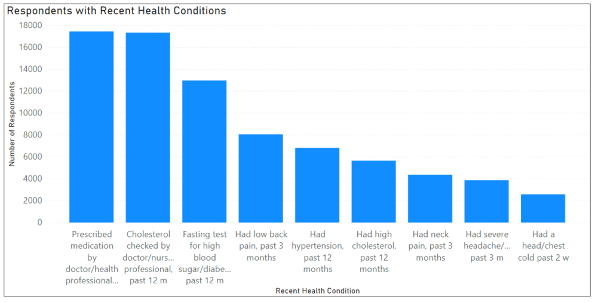

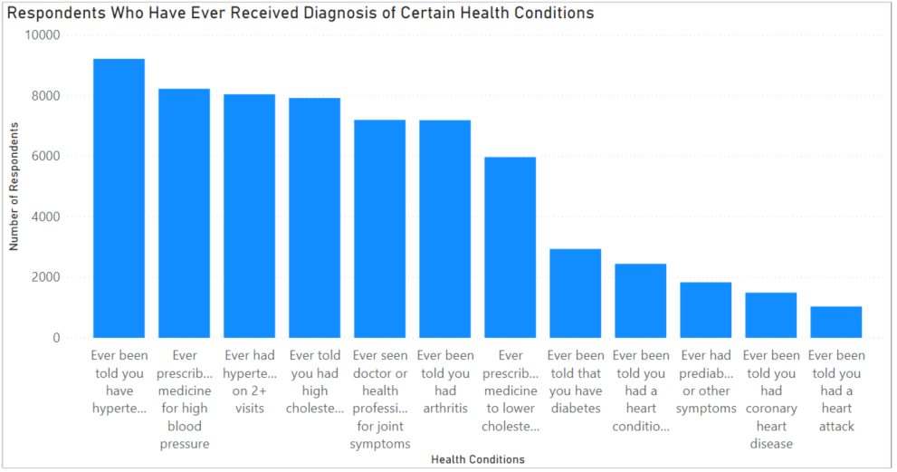

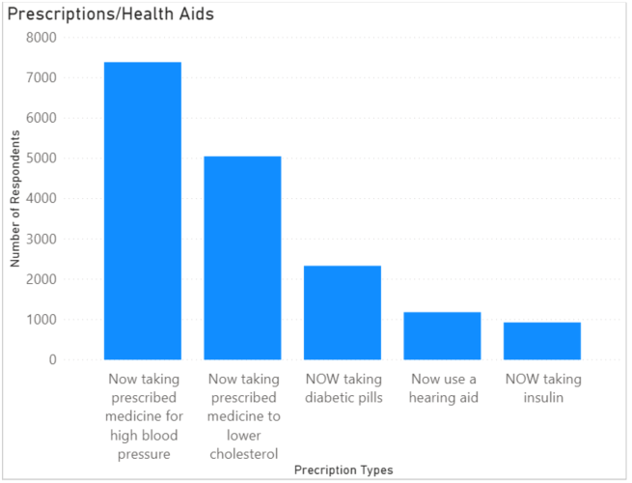

The graphs revealed that most people were satisfied with their health care coverage. While respondents reported a number of health concerns and diagnoses, they have also visited their doctors and have access to medications. The most significant finding was the paid sick leave. Over 40% of respondents do not have paid sick leave from their employer.

Logistic regression models were created using the “person” file. The purposes of the models were to test for significant correlations among several of the variables. Models were created to test the following: Delaying medical care or not seeking medical care based on the respondent not having insurance coverage; Not seeking medical care based on type of insurance, such as Medicaid, Private, Military, etc.; Not seeking medical care based on each type of insurance individually; Having coverage for cancer or accident but not seeking medical care; Each type of coverage but didn’t seek medical care; and No employer coverage and didn’t seek medical care or delayed care. Data was split into training and testing sets.

The “person” and “sample adult” files were merged into a combined file for a deeper look at paid sick time. Since the sample adult file is randomly selected from the person file, the data set decreased in number of records accordingly. More logistic regression models were created to study the correlation between paid sick leave and the respondent not seeking or delaying medical care. Training and testing sets were created from the combined data, and additional modeling was performed using these data sets.

Results

The modeling results from the “person” file were somewhat disappointing. There was a correlation between not having health coverage and not seeking medical care, or delaying medical care, but this was to be expected. Modeling with the different types of insurance coverage did not suggest any correlation between the different coverage types and not seeking/delaying medical care. Therefore, there was no clear finding in any of the models to demonstrate which would indicate a particular insurance than an employer should or should not offer to employees. Because the analysis revealed significance with the paid sick leave, the focus shifted to the modeling with the combined file.

The regression models using the combined data set focused on paid sick leave as an indicator of whether or not a respondent would delay or not seek getting medical care. The models showed a significant correlation that when a respondent has paid sick leave, they are less likely to not seek medical care, and are less likely to delay getting medical care. Therefore, having paid sick leave is a significant indicator that a respondent will seek medical care in a timely manner. While there is also significant correlation between gender and seeking or delaying care, this is not a factor that an employer can influence. The focus of the study was to look for variables in the health survey that an employer would be able to impact in a favorable way. The modeling revealed that paid sick leave is a significant variable, and a variable that an employer could act on.

Discussion/Conclusion

After looking through the difference relationships between health insurance coverage and usage, it appears there is a significant correlation between having paid sick time and going to the doctor. When paid sick time is available, the person is less likely to delay or not seek medical assistance. Being able to seek health care, as needed, is a benefit that employers can offer. Having a good paid sick time policy could be an attractive benefit to offer employees.

Acknowledgments

I would like to acknowledge the in depth surveys made available to the public by the National Center for Health Statistics. I would also like to acknowledge Professor Williams at Bellevue University for her feedback and thoughts throughout this term regarding this project. I would also like to thank my husband for his patience of my many hours of research, and also his willingness to let me bounce ideas off of him. Finally, I would like to thank my employer for their tuition assistance that has made college affordable.

References

National Center for Health Statistics. (2019). Survey Description. Hyattsville, Maryland: National Health Interview Survey, 2018.